Ohio Pre-SSLI Equity Workshop

Definitions
Equity | The state, quality or ideal of being just, impartial and fair. The concept of equity is synonymous with fairness and justice. It is helpful to think of equity as not simply a desired state of affairs or a lofty value. To be achieved and sustained, equity needs to be thought of as a structural and systemic concept.
Poverty | Living without the basic necessities of life – food, clothing or housing.
Poverty Rate | Poverty is measured in the United States by comparing a person’s or family’s income to a set poverty threshold or minimum amount of income needed to cover basic needs. People whose income falls under their threshold are considered poor.
Intersectionality | The interconnected nature of social categorizations such as race, class, and gender as they apply to a given individual or group, regarded as creating overlapping and interdependent systems of discrimination or disadvantage.
Equity/Opportunity Gap | An alternative to the phrase “achievement gap” that recognizes the inequality of opportunity in education, or “education debt,” characterized by a long history of discriminatory gaps in educational inputs such as a school’s number of teachers, the quality of its facilities, and the availability of textbooks.
Design Thinking | A protocol for solving complex problems.
Systems Thinking | A holistic approach to analysis that focuses on the way that a system's constituent parts interrelate and how systems work over time and within the context of larger systems.
Student Success | The outcome of a personal, rigorous, and enriching learning experience that culminates in the achievement of students’ academic goals in a timely manner and fully prepares them to realize their career aspirations.
Holistic Student Supports | The cohesive suite of services that help students address the academic and non-academic factors vital to retention and completion.
SSIPP | - Sustained: Ongoing support rather than an “inoculation” approach.  - Strategic: Limited resources, not all students need all services and leverage external partnerships.  - Integrated: To create a seamless experience rather than a set of stand-alone services. Integrate services, technologies, departments, data, “student success initiatives” etc.  - Proactive: Provide supports we know are needed before obstacles reach crisis point.  - Personalized: Know your student, building relationships with intentionality, systems and processes that flex to meet the student where they are.
Structural Change | Occurs when policies, structures, and procedures create a framework for new behaviors that improve the student experiences throughout the institution. Within a holistic approach, this might yield organizational redesign or policy changes that encourage long-term relationships between students and advisors.
Process Change | Alters how people do their job and is transformative when enough individuals change their practices to ensure that large numbers of students encounter new student support interactions. A holistic approach might involve a) perceiving advising as a function of teaching and b) drawing on case management principles to support students.
Attitude Change | Occurs when individuals understand their work and view work processes in new ways. Attitudinal change is evident when academic and non-academic supports are naturally and commonly understood to be one interconnected process and essential for the effectiveness of the college’s teaching and learning functions.
Level 1 Change | These are changes primarily based in individual attitude, behavior and/or choice. College employees can make a change at this level with deep personal commitment and these changes often involve commitment to adopting a new approach and adapting that approach in daily work.  This includes working with faculty and frontline staff to identify student engagement strategies, internal service standards, and communication practices to improve student touchpoints, accuracy of information, and timeliness of referrals.
Level 2 Change | These are changes primarily based at the department or unit support level requiring support from department/unit/division leadership to work as a group to make these changes, and require leadership endorsement, resources, and facilitation to ensure a cohesive approach.  This includes working with academic, student services, and operations unit leaders to identify opportunities for coordinated efforts, communication practices to improve collaborative intervention design and delivery, establish common definitions, and establish clarity on roles and shared responsibilities.
Level 3 Change | These changes require executive level support, endorsement, resources, and institutional prioritization to achieve. They may involve policy, scaled practices across the institution, and structural changes to ensure the college has the foundation to achieve a stated goal or strategy at a systems level.  This includes working with executive leaders to identify policy recommendations, structural changes to support sustainable change, faculty and staff professional development needs at scale, faculty engagement strategies, integration points for high impact practices, and college systems opportunities and gaps.

Develop a Campus Definition of Equity
Individually, reflect on the following questions. Use the box below to make notes.
- What does equity mean to your college?
Then, as a team discuss your perspectives and come to a shared working definition of equity to ground your work. Consider your college and community context and the needs of your students as well as what parts of addressing equity are within your college’s control.
Next, identify the student population(s) you will focus on.
Student Population:

Build a Student Profile
As a team, complete the following table to develop your own persona for your student population. This will be used later on as you develop strategies to address the challenges you identified earlier.
Student Persona Name
Goals (Identify the goals of this student)
Biographical Characteristics
Personal Responsibilities
Strengths
Values/Attitudes
Stress Points

Design Principles
What equity challenges have you identified at your college? How are you planning to address those challenges? Then, write down some of the key aspects of your desired approach and identify the design principles you are incorporating. Are there any design principles missing in your approach?
- Sustained: Ongoing support rather than an “inoculation” approach.
- Strategic: Limited resources, not all students need all services and leverage external partnerships.
- Integrated: To create a seamless experience rather than a set of stand-alone services. Integrate services, technologies, departments, data, “student success initiatives” etc.
- Proactive: Provide supports we know are needed before obstacles reach crisis point.
- Personalized: Know your student, building relationships with intentionality, systems and processes that flex to meet the student where they are.
 | Challenge | Planned Approach
ONE
TWO
THREE
Digging Deeper into How the College Works
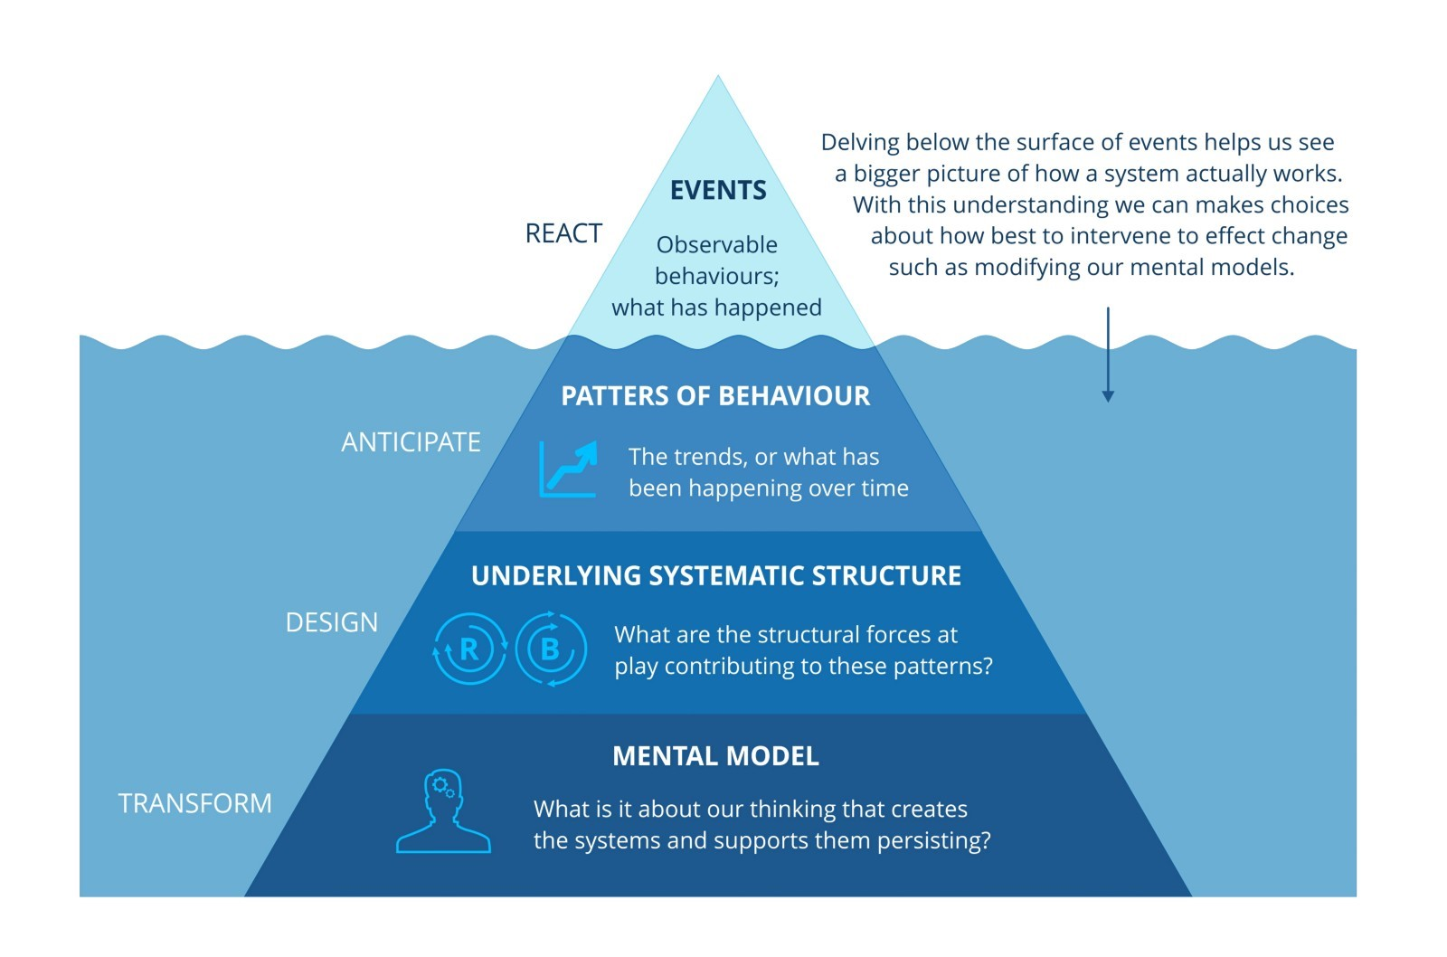The Iceberg Model (Northwest Earth Institute, 2017)

Community Mapping Exercise
Complete the following table as a team.
Our College Definition of Equity
Our Population of Focus
What Do We Want to Explore?
Current Student Profile
Who are our current students who fit this profile? What do we know about them? Consider demographics, where they live, etc.
Previous Educational Experiences
What are the previous educational experiences of this student population? How might that influence their needs?
Proactive College
How does my college intentionally and proactively communicate with this student population on campus and in the community?
Passive College
How does my college passively communicate with this student population on campus and in the community?
Community profile
Who are the people in the community not attending my college that fit this profile? Look for community/county/city profile information.
Policies to support this student population
What policies does my college have that are designed to support the success of this student population?
Structures to support this student population
What structures are in place at my college to support this student population?
Needs Identification
What support needs does this student population have?
Need Availability
What supports are available at the college and or in the community that can address these needs?
Need Gaps
What needs are not met by available services?
What barriers to accessing these available services exist for this group?

Identifying Types & Levels of Change
Identify the changes you need to make to address the challenge identified. Be sure to consider changes to structures, processes, and attitudes. Then, identify the level of change this reflects based on the definitions below the table.
Please refer to pages 2 and 3 of this worksheet for the definitions of the three levels of change.
Types of Change | Describe the Changes | Level of Change
Structural
Process
Attitudinal

Action Plan
As a team, identify at least three actionable changes, the level of those changes, and an actionable next step in addressing those changes, along with a timeframe.
Actionable Changes | Level of Change | Immediate Next Steps | Due Date for Next Steps | Lead Individual

